

**Recent Changes to the Provider Qualification Documentation Record (PQDR)**

1. **Tab 1. Instructions**

Effective January 1, 2021, the PQDR was updated to be used by all ODP providers for the Consolidated, Community Living, PFDS, and Autism waivers. On the PQDR, we are referring to the Consolidated, Community Living, and PFDs waivers as ID/A and the Adult Autism Waiver as AAW. In an effort to prevent confusion, there are new instructions on the Instructions Tab. These instructions explain how green tabs apply to all agencies, Blue Tabs pertain to ID/A providers only, and Orange tabs apply to AAW providers only.

The instructions further direct providers that if they are enrolling/enrolled to provider services in both ID/A and AAW waivers, they will complete/refer to all tabs on the PQDR:

* If they are enrolled/enrolling to provide services in ID/A waivers only, they would complete/refer to the Green and blue tabs.
* If they are enrolled/enrolling to provide services in the Adult Autism Waiver only, they would complete/refer to the green and orange tabs.
* There are also additional instructions on where to submit the PQDR and supporting documentation and naming conventions for the PQDR.

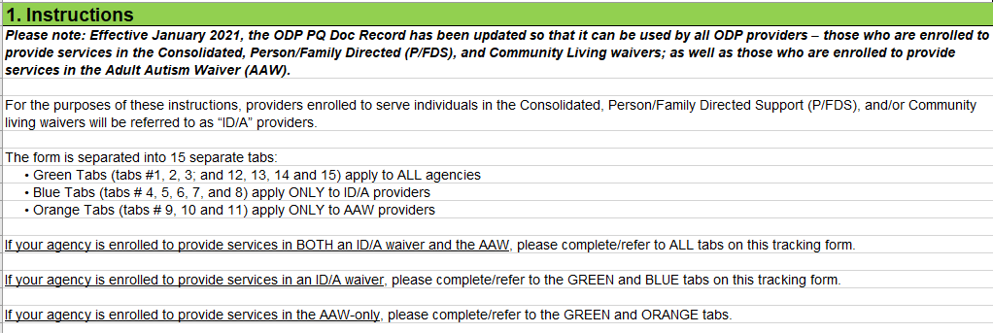

1. **Previous PQDR had 12 Tabs the New PQDR has 15 Tabs:**

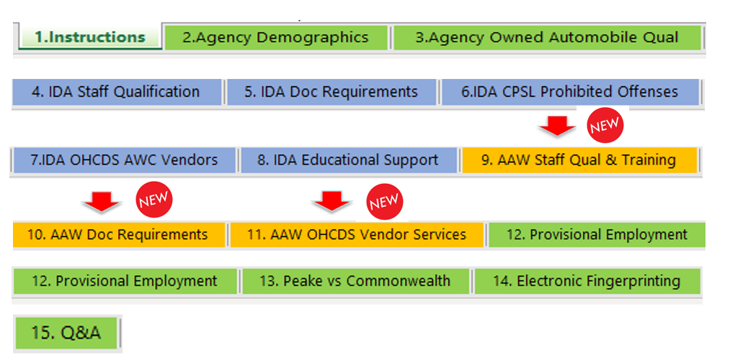

1. **Tab 1. Instructions: Links and paths to trainings were added:**

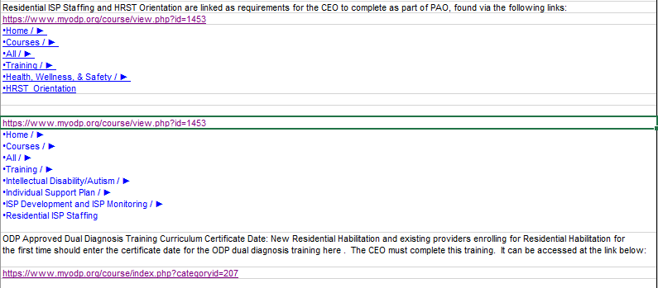

1. **Tab 1. Instructions: Under number “7” instructions were added for the ID/A OHCDS AWC Vendor Tab:**

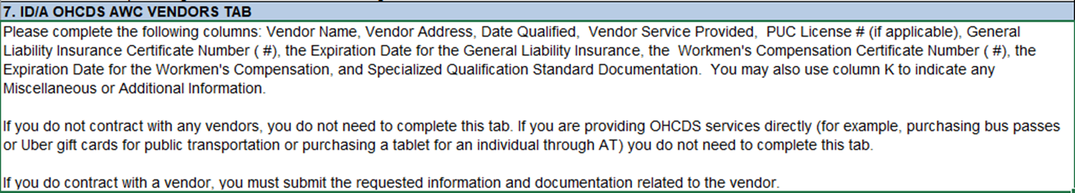

1. **Tab 2. Agency Demographics: It now states that the CEO must complete trainings below and they must supply the date and/or number of the certificate and include a copy with the supporting documentation:**

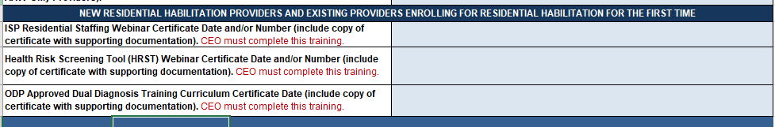

1. **Tab 2. Agency Demographics: It now states that for ID/A providers, verification of access to a Certified Investigator is evaluated during QA&I:**

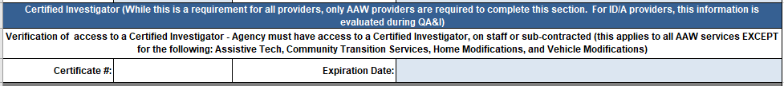

1. **Tab 2. Agency Demographics: It now states that Successful Completion of the New Provider Self-Assessment Tool is not applicable to AAW Only Providers:**



1. **Tab 2. Agency Demographics: New ID/A Providers must now indicate the date of confirmation email for the QA&I contact form and include a copy of the email with supporting documentation:**



1. **Tab 5. IDA Doc Requirements: Respite Licensed (52. Community Residential Rehabilitation, 513. Respite Care Out of Home) was separated from Respite Licensed, Unlicensed and additional clarification was added from the ISP Manual:**

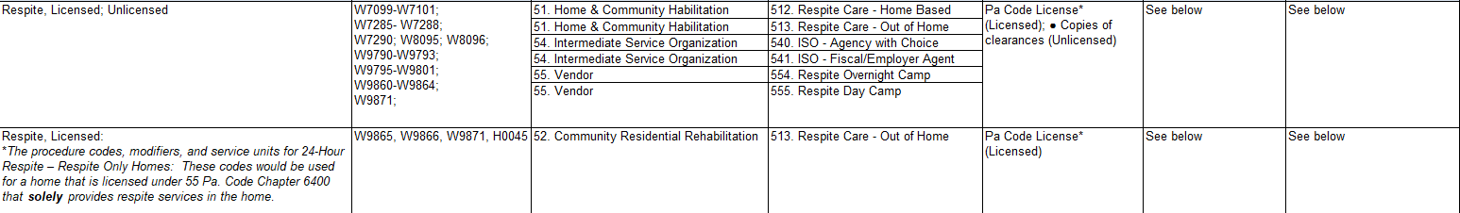

1. **Tab 14. Electronic Fingerprinting: New code added for unlicensed providers:**

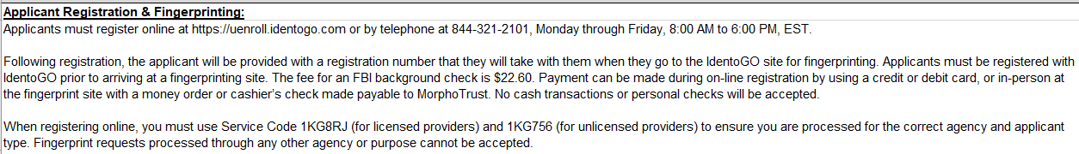

1. **Tab 15. Q&A: Has been modified to allow providers to search questions and answers by AAW only, ID/A only, or IDA/AAW:**

